Final Project: Part 1

Jesse Roberts

Step 1 - Business Rules:

* A title may have one, or two ISBNs, an ISBN may only have one title
* An ISBN may be 10 digits
* A title may have one or many authors
* A title usually has one publisher, a publisher can have one or many books
* An author may have one or many books (authors with zero books are not relevant to this library)
* A title may have one or many pages, pages may only have one title
* A title can only belong to one category, a category can have many books
* A book can only be donated by one friend
* A title can only have been purchased for one price
* A title can have one or many subject matters, and a subject matter zero or many books
* A title/ISBN can only have one year, but a year many titles
* A friend may have zero or many books, a book can only be checked out by one friend at a time
* A book can only be borrowed (checked out, in, length of time) once at a time

Step 2 – Relational Schema



Step 3 – Entity Relationship Model

I edited this for part two because I realized my friends table didn’t make sense, so this resembles your example more.

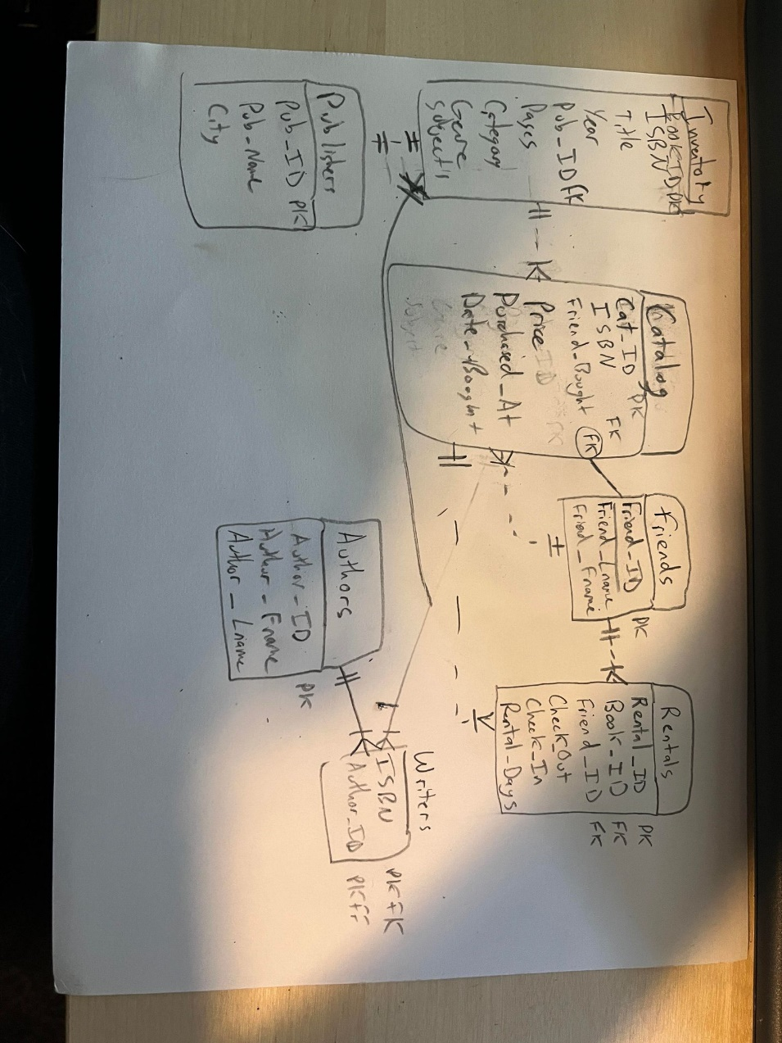

Step 4: Data Dictionary

5.

Indexes:

1. ISBN (unique to each book, would work for catalog and inventory)
2. Friend_ID (Need to easily query which friend belongs to which ID in case of rentals)
3. Book_ID (unique to each copy of a book, in case a copy gets lost or its sticker comes off)
4. Rental_ID (quickly discover what books were checked out in a rental
5. Author_ID (quickly determine who wrote a specific book to seek out more books by same author)

Part 6:

CREATE TABLE `authors` (

  `Author_ID` varchar(3) NOT NULL,

  `Author_Fname` varchar(20) DEFAULT NULL,

  `Author_Lname` varchar(20) DEFAULT NULL,

  PRIMARY KEY (`Author_ID`),

  UNIQUE KEY `Author_ID_UNIQUE` (`Author_ID`)

)

CREATE TABLE `catalog` (

  `Cat_ID` int NOT NULL,

  `ISBN` char(10) NOT NULL,

  `Friend_Bought` varchar(2) NOT NULL,

  `Price` double(5,2) DEFAULT NULL,

  `Purchased_At` varchar(20) DEFAULT NULL,

  `Date_Bought` date DEFAULT NULL,

  PRIMARY KEY (`Cat_ID`),

  UNIQUE KEY `Cat_ID_UNIQUE` (`Cat_ID`),

  UNIQUE KEY `ISBN_UNIQUE` (`ISBN`),

  KEY `Friend_Bought_idx` (`Friend_Bought`),

  CONSTRAINT `Friend_Bought` FOREIGN KEY (`Friend_Bought`) REFERENCES `friends` (`Friend_ID`),

  CONSTRAINT `ISBN` FOREIGN KEY (`ISBN`) REFERENCES `inventory` (`ISBN`)

)

CREATE TABLE `friends` (

  `Friend_ID` varchar(2) NOT NULL,

  `Friend_Lname` varchar(20) NOT NULL,

  `Friend_Fname` varchar(20) NOT NULL,

  PRIMARY KEY (`Friend_ID`),

  UNIQUE KEY `Friend_ID_UNIQUE` (`Friend_ID`)

)

CREATE TABLE `inventory` (

  `Book_ID` varchar(4) NOT NULL,

  `ISBN` char(10) NOT NULL,

  `Title` varchar(30) NOT NULL,

  `Year` int DEFAULT NULL,

  `Pub_ID` varchar(3) NOT NULL,

  `Pages` int NOT NULL,

  `Category` varchar(20) NOT NULL,

  `Genre` varchar(10) DEFAULT NULL,

  `Subject` varchar(15) DEFAULT NULL,

  PRIMARY KEY (`Book_ID`),

  UNIQUE KEY `Book_ID_UNIQUE` (`Book_ID`),

  UNIQUE KEY `ISBN_UNIQUE` (`ISBN`),

  KEY `Pub_ID_idx` (`Pub_ID`),

  CONSTRAINT `Pub_ID` FOREIGN KEY (`Pub_ID`) REFERENCES `publishers` (`Pub_ID`)

)

CREATE TABLE `publishers` (

  `Pub_ID` varchar(3) NOT NULL,

  `Pub_Name` varchar(20) NOT NULL,

  `City` varchar(20) NOT NULL,

  PRIMARY KEY (`Pub_ID`),

  UNIQUE KEY `Pub_ID_UNIQUE` (`Pub_ID`)

)

CREATE TABLE `rentals` (

  `Rental_ID` varchar(4) NOT NULL,

  `Book_ID` varchar(4) NOT NULL,

  `Friend_ID` varchar(2) NOT NULL,

  `Check_Out` date DEFAULT NULL,

  `Check_In` date DEFAULT NULL,

  `Rental_Days` int DEFAULT NULL,

  PRIMARY KEY (`Rental_ID`),

  UNIQUE KEY `Rental_ID_UNIQUE` (`Rental_ID`),

  KEY `Book_ID_idx` (`Book_ID`),

  KEY `Friend_ID_idx` (`Friend_ID`),

  CONSTRAINT `Book_ID` FOREIGN KEY (`Book_ID`) REFERENCES `inventory` (`Book_ID`),

  CONSTRAINT `Friend_ID` FOREIGN KEY (`Friend_ID`) REFERENCES `friends` (`Friend_ID`)

)

CREATE TABLE `writers_written` (

  `ISBN` char(10) NOT NULL,

  `Author_ID` varchar(3) NOT NULL,

  PRIMARY KEY (`ISBN`,`Author_ID`),

  KEY `Author_ID_idx` (`Author_ID`),

  CONSTRAINT `Author_ID` FOREIGN KEY (`Author_ID`) REFERENCES `authors` (`Author_ID`),

  CONSTRAINT `ISBN(10)` FOREIGN KEY (`ISBN`) REFERENCES `inventory` (`ISBN`)

)